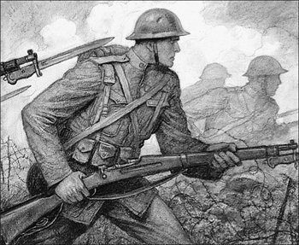
World History
WWI Menu Project

The goal of this project is to showcase your knowledge and creativity of WWI through one of the following options. You MUST address one of the essential questions for the unit within your project. You have an option to complete this project individually or in a group of 2-3 students.

Dates in the Media Center: ____________________________
Due Date of Final Project: _____________________________

Individual Project Options:

- Biography of Women - Write 2-3 pages biography of an important woman during WWI. Please be sure to illustrate the effect she had on WWI as well as the status and view of women during the time period.
- WWI Music Playlist – Create a CD/Playlist of WWI music. Analyze lyrics and music of the songs as primary sources. For each song, you should summarize your analysis by explaining the country of origin, message of the lyrics, and what they reveal about the nature of WWI and/or the people who lived during this time.
- US Congress Speech – Prepare a persuasive speech for delivery to the US Congress based on the following question “Why the US should/should not become involved in WWI?”. Your speech must clearly reflect the political realities in US before the entry of war. Speech should be 2-3 pages and must be recorded.
- WWI Art Padlet/Mosaic – Create a large mosaic that portrays the psychological and emotional experiences of the war. It should depict multiple events and/or trends of WWI. You may choose to incorporate propaganda images, maps, etc. A 1-2 page paper should accompany your mosaic or each padlet entry should have a description of WWI.
- Create an idea for an original project that reflects your understandings of WWI. Your project must include both a creative representation of your understandings of the war and at least 1-2 pages written reflection. Your teacher must approve project idea!

Group Project Options:

- WWI Board Game Project – Create a board game that demonstrates the history of WWI. It should not be a trivia game but must include understanding of the history of WWI though the playing board, game pieces, and rules.
- WWI Time Capsule – Imagine you were present during WWI (soldier, nurse, civilian) and you create a time capsule to capture your experiences during WWI for the benefit of future generations.
- WWI Newspaper – Create a newspaper that reports on a variety of aspects of the war including the long and short-term causes of the Great War, propaganda, WWI battles, American involvement and the end of the war.
- WWI Video/Skit – Create a 5-7 minute video or script that demonstrates your knowledge of WWI. An annotated script must accompany each video.
- Create an idea for an original project that reflects your understandings of WWI. Your project must include both a creative representation of your understandings of the war and at least 1-2 pages written reflection. Your teacher must approve project idea!

**Please see attached descriptions/rubrics for each individual project option!**

